

Experiment 1.2

Student Name: ADITYA RAJ UID: 21BCS8948

Branch: CSE Section/Group: ONBCS703-A

Semester: 3rd Date of Performance: 31-08-2022

Subject Name: Database Management System Subject Code: 21CSH-214

- Aim/Overview of the practical: To explore “SELECT” clause using where, order by, between, like, groups by, having etc.

- Source Code with output:

- Consider a relation Employee with following attributes:

Name Type

EMPNO NOT NULL NUMBER (4)
ENAME VARCHAR2 (10)
JOB VARCHAR2 (9)
MGR NUMBER (4)
HIREDATE DATE
SAL NUMBER (7, 2)
COMM NUMBER (7, 2)
DEPTNO NUMBER (3)
AGE NUMBER (3)
ESAL NUMBER (10)

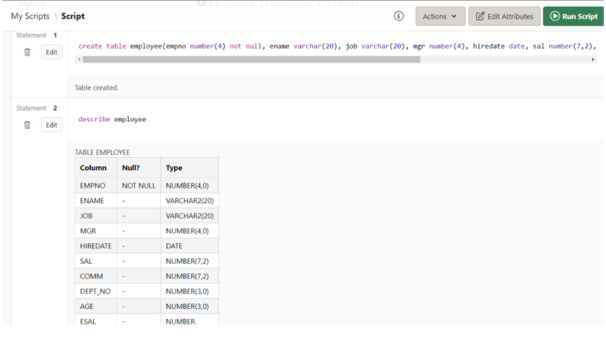

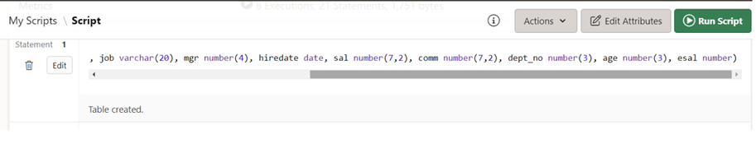

a. List minimum, maximum , average salaries of employee.
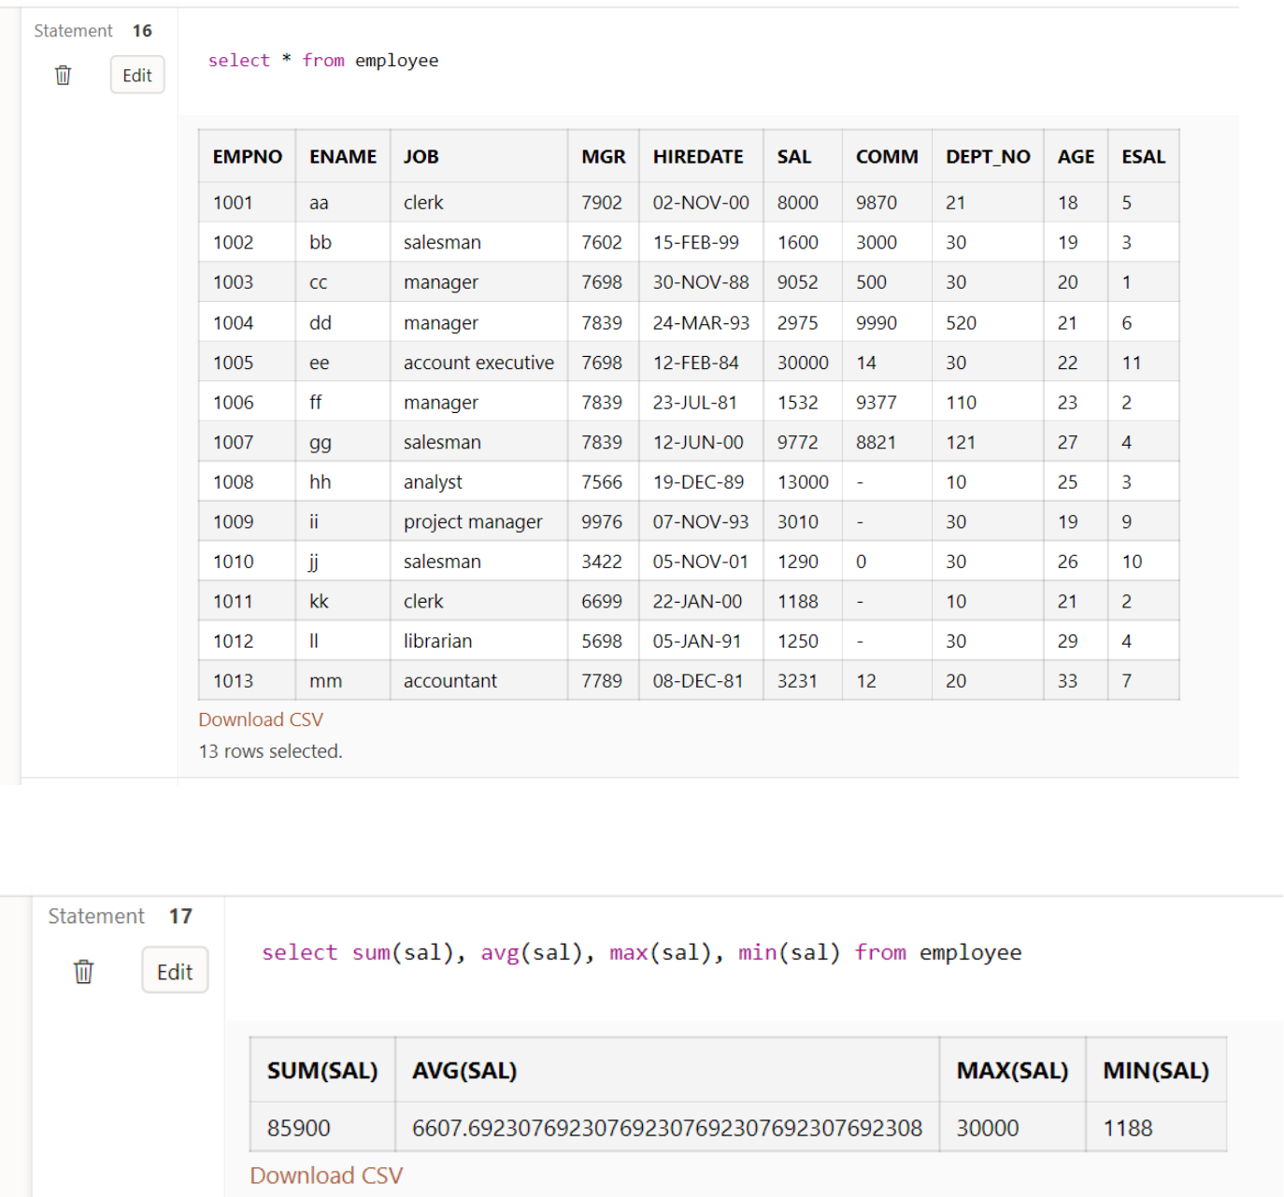

- What is the difference between maximum and minimum salaries of employees in the organization?
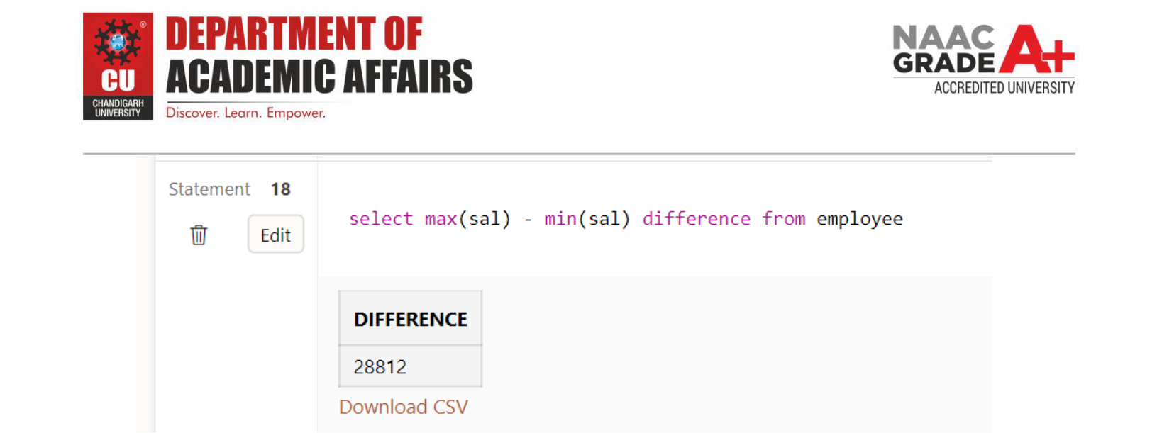

- Display all employee names and salary whose salary is greater than minimum salary of the company and job title starts with “M”.
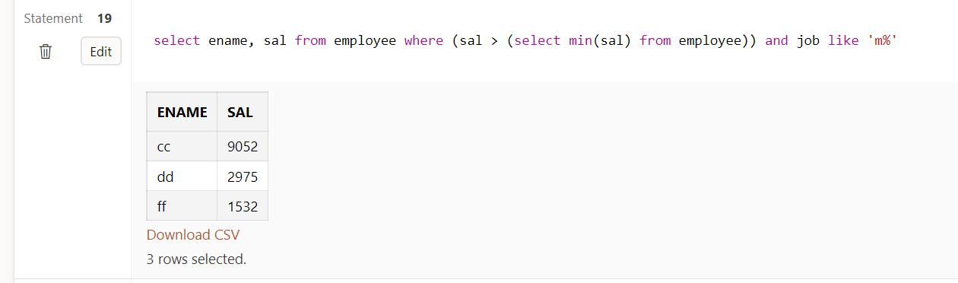
d. Display total salary spent for each job category.
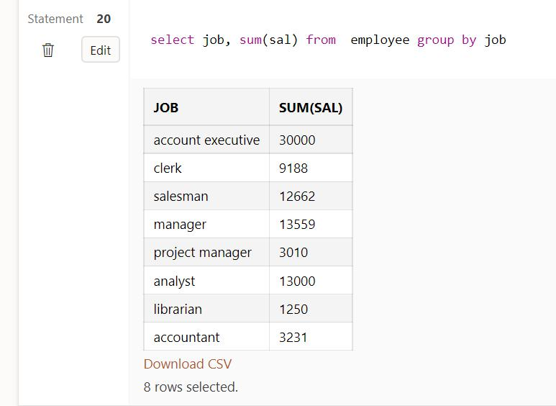

e. Display lowest paid employee details under each manager.
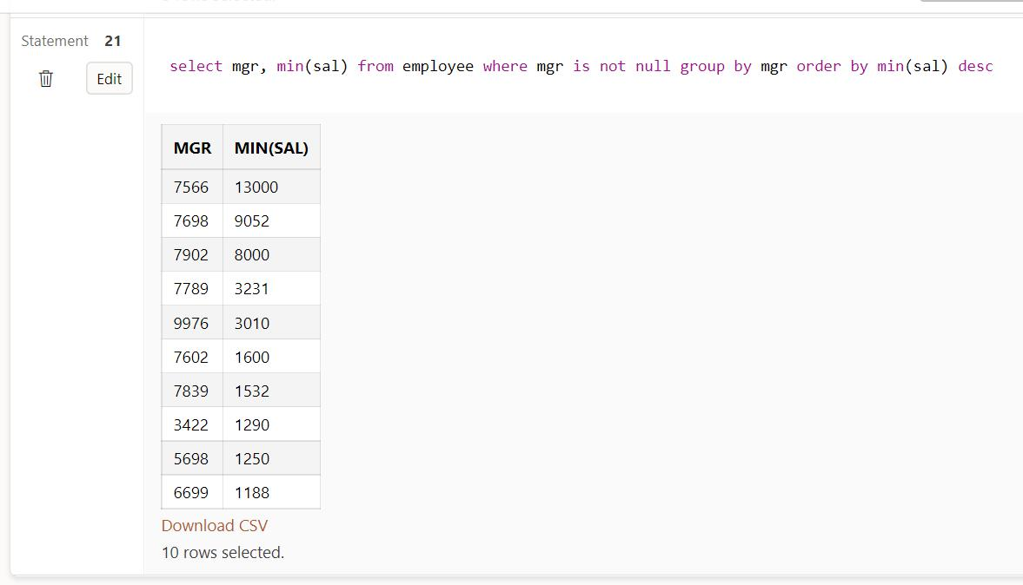

Q2. Create table emp with attributes (eid number, ename varchar2 (10), age number,salary number);
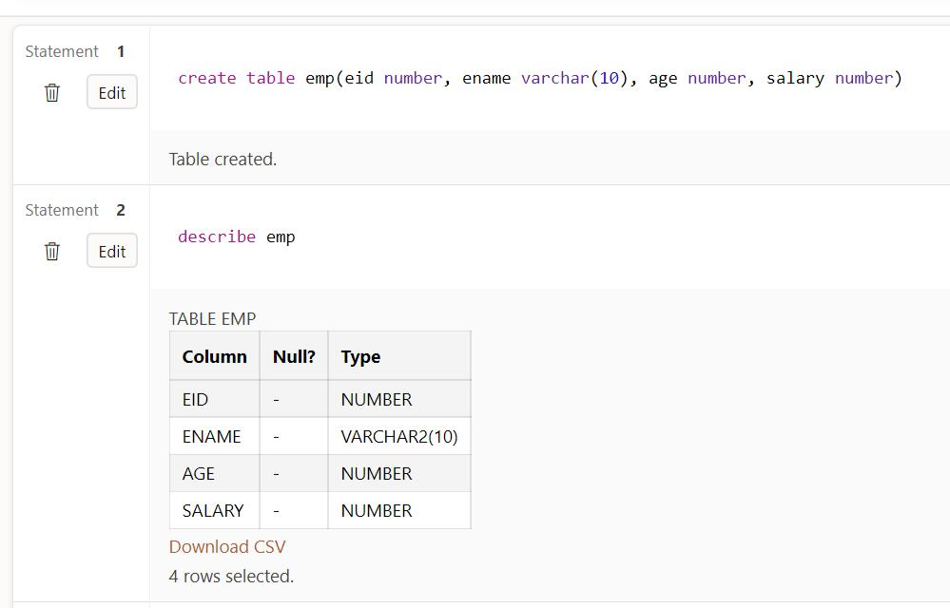
a. Count number of employee names from employee table.
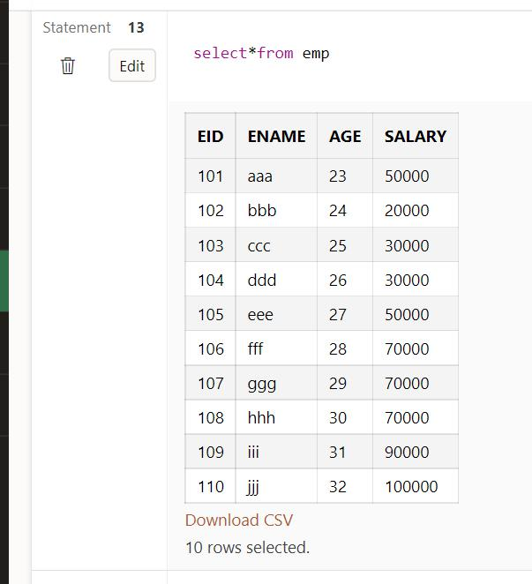
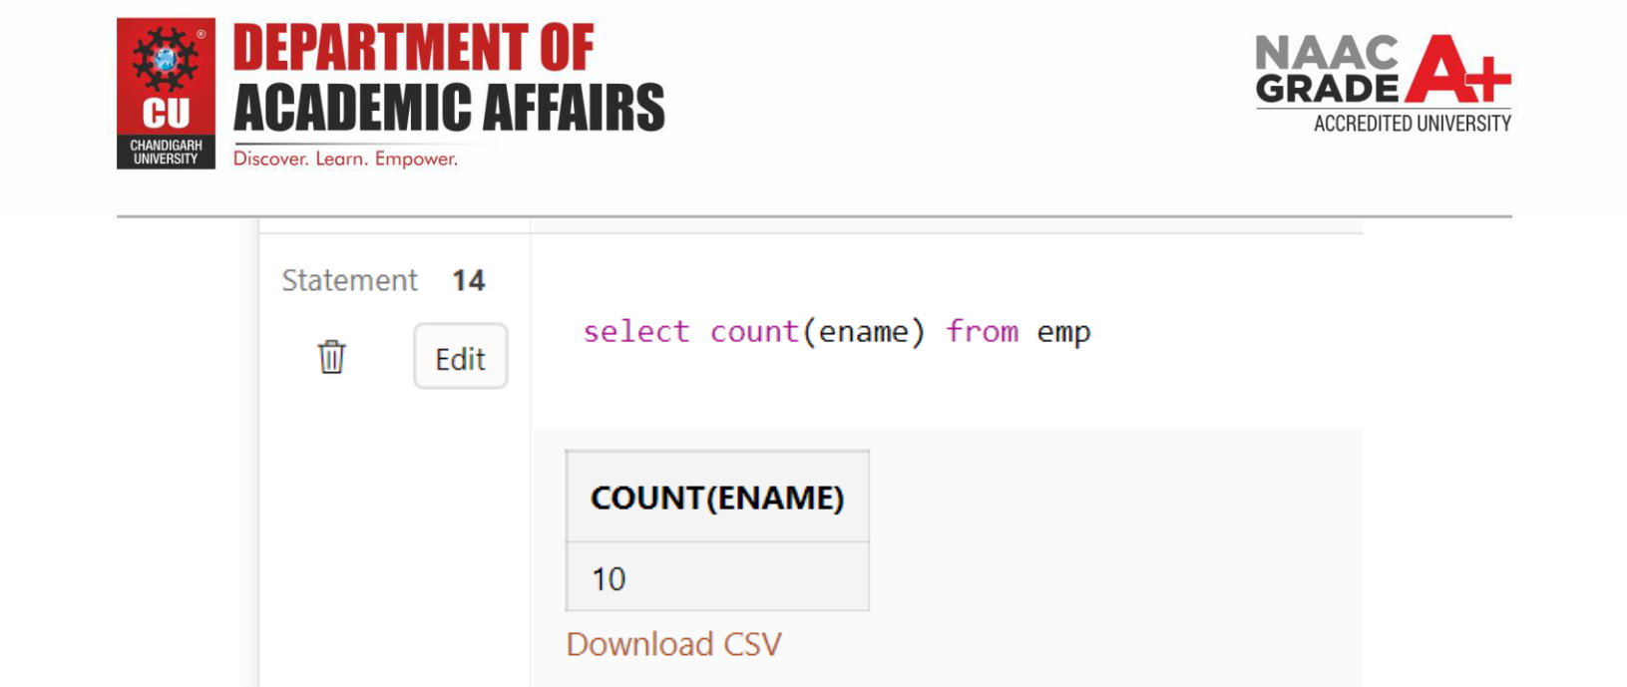

b. Display the Sum of age employee table
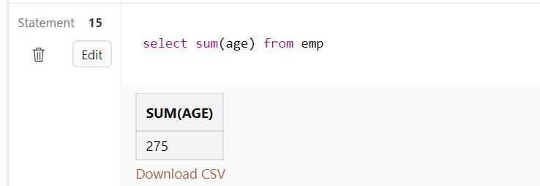
c. Find grouped salaries of employees (group by clause).
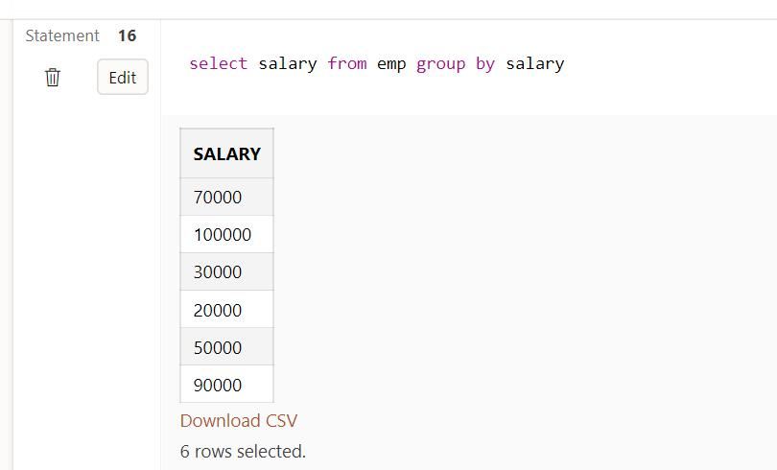
d. Find salaries of employee in Ascending Order (order by clause).
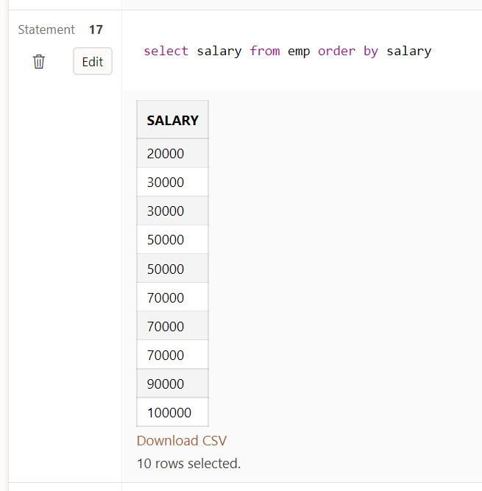
e. Find salaries of employee in Descending Order.
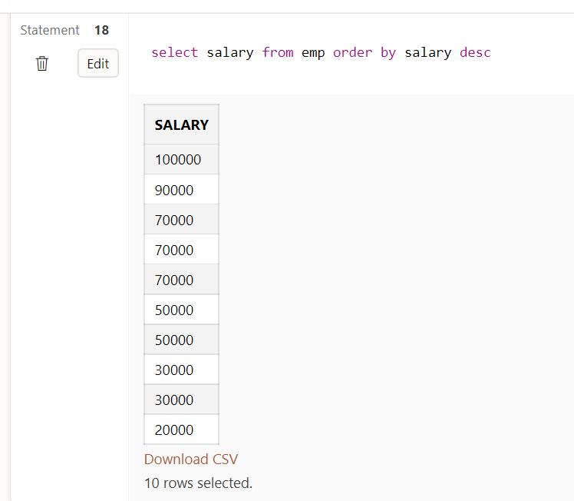
Q3. Consider the database for a college. Write the query for the following.
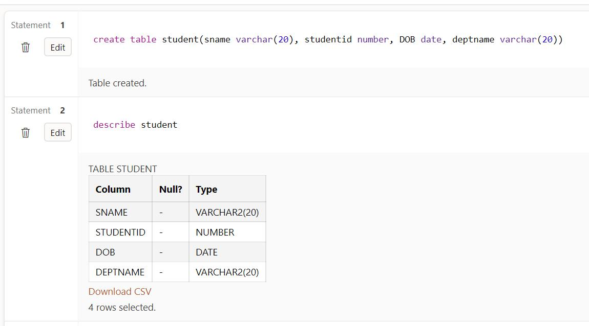
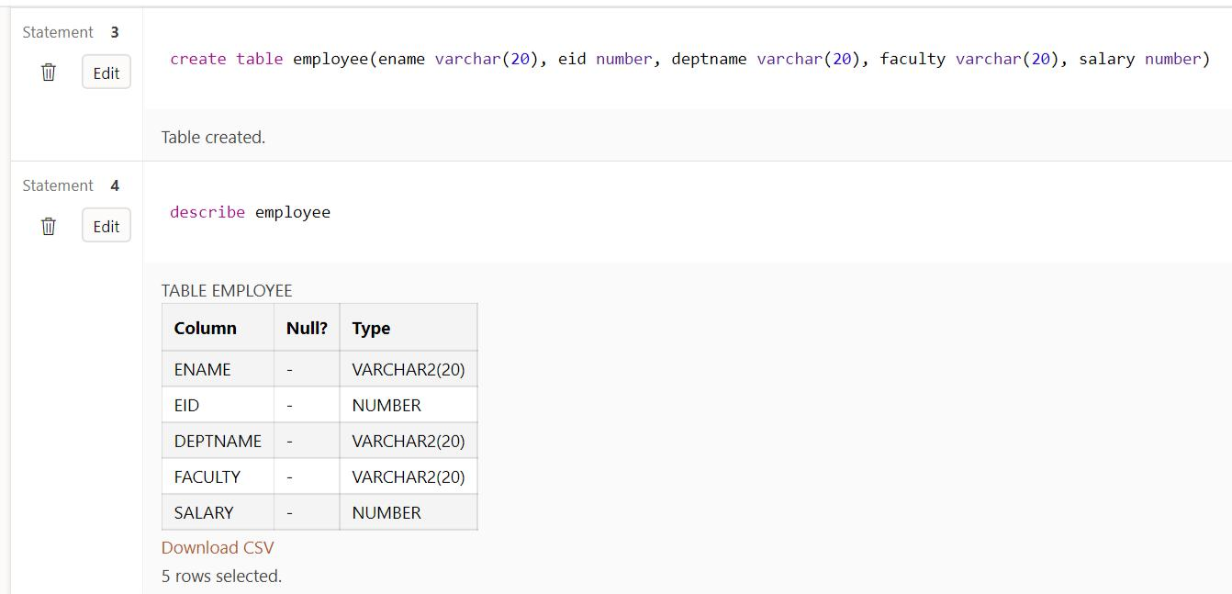
Insert at least 5 tuples into each table.
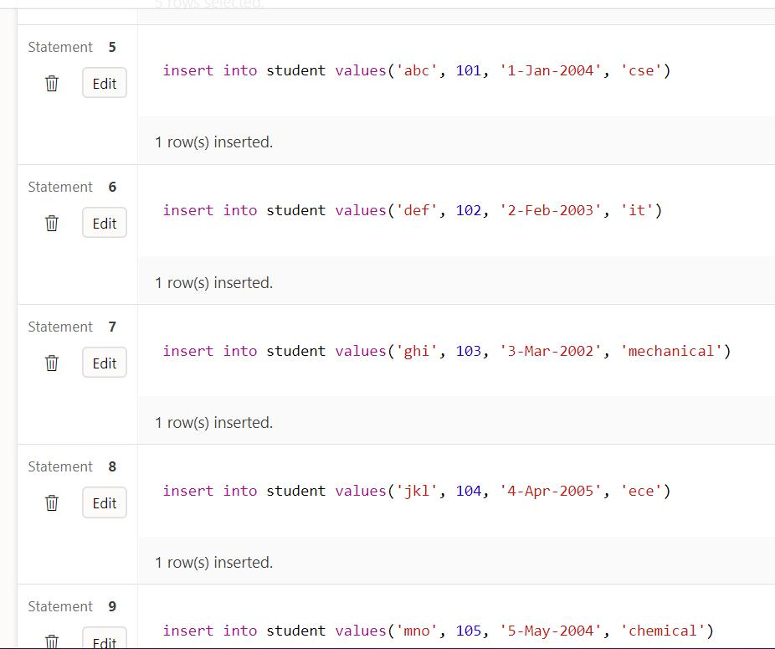
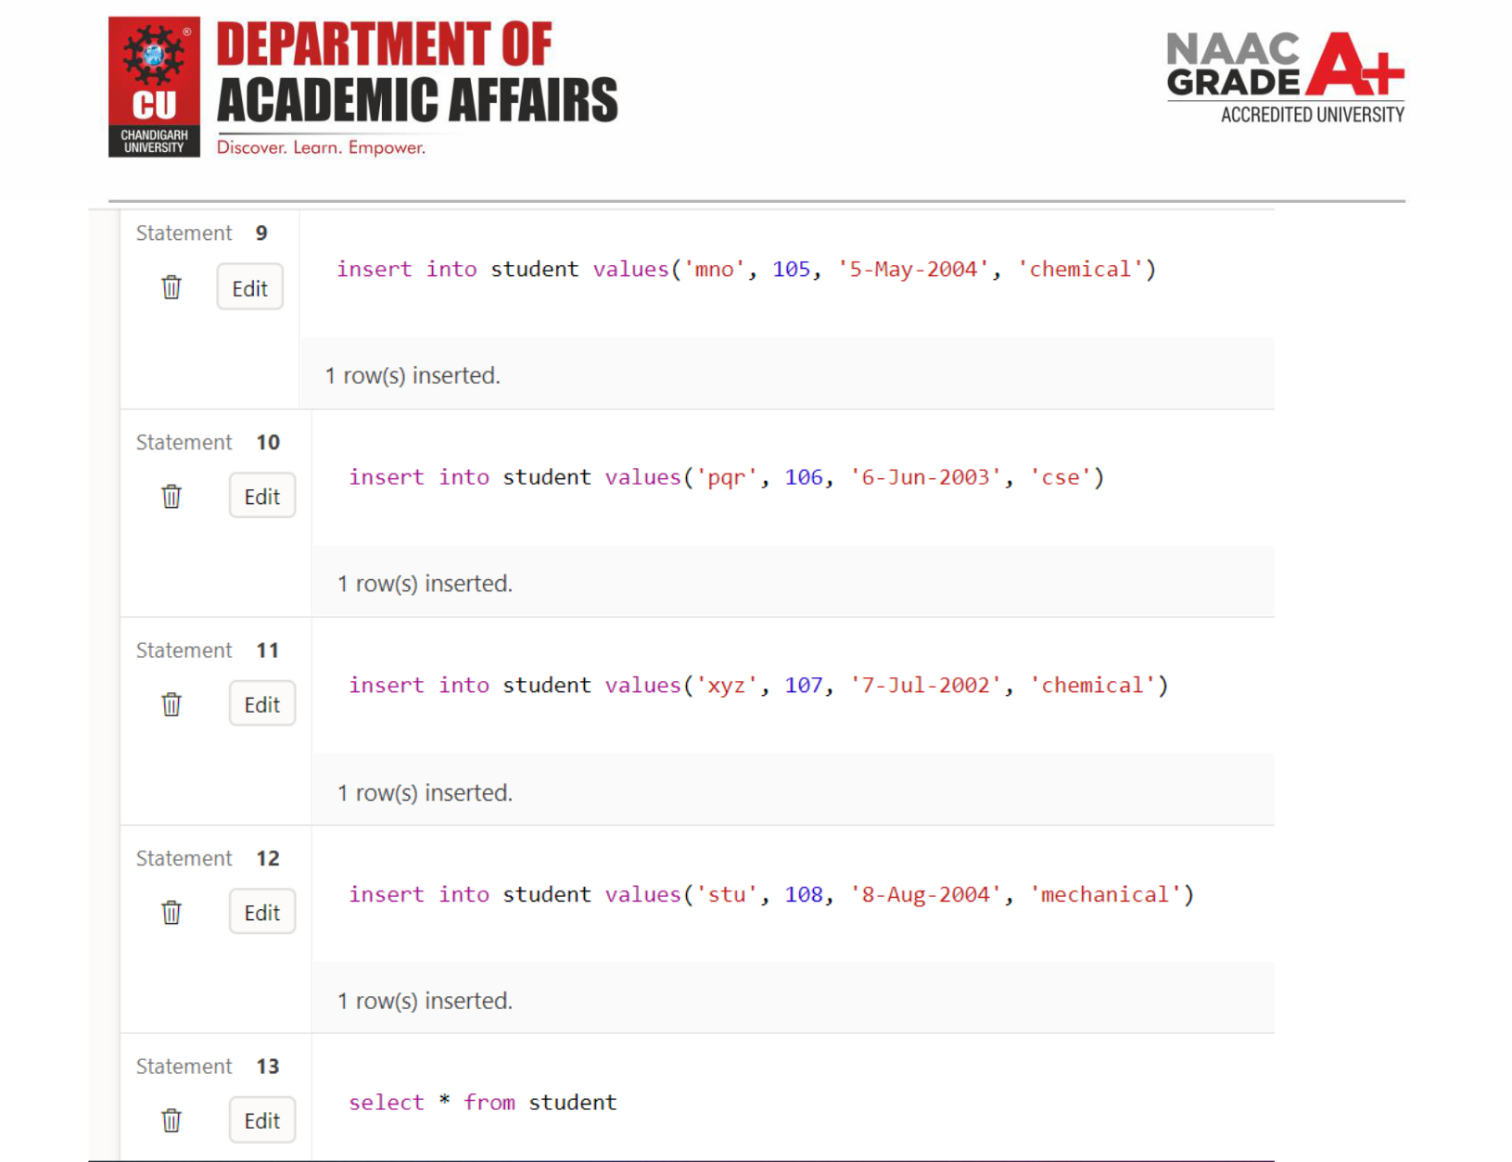
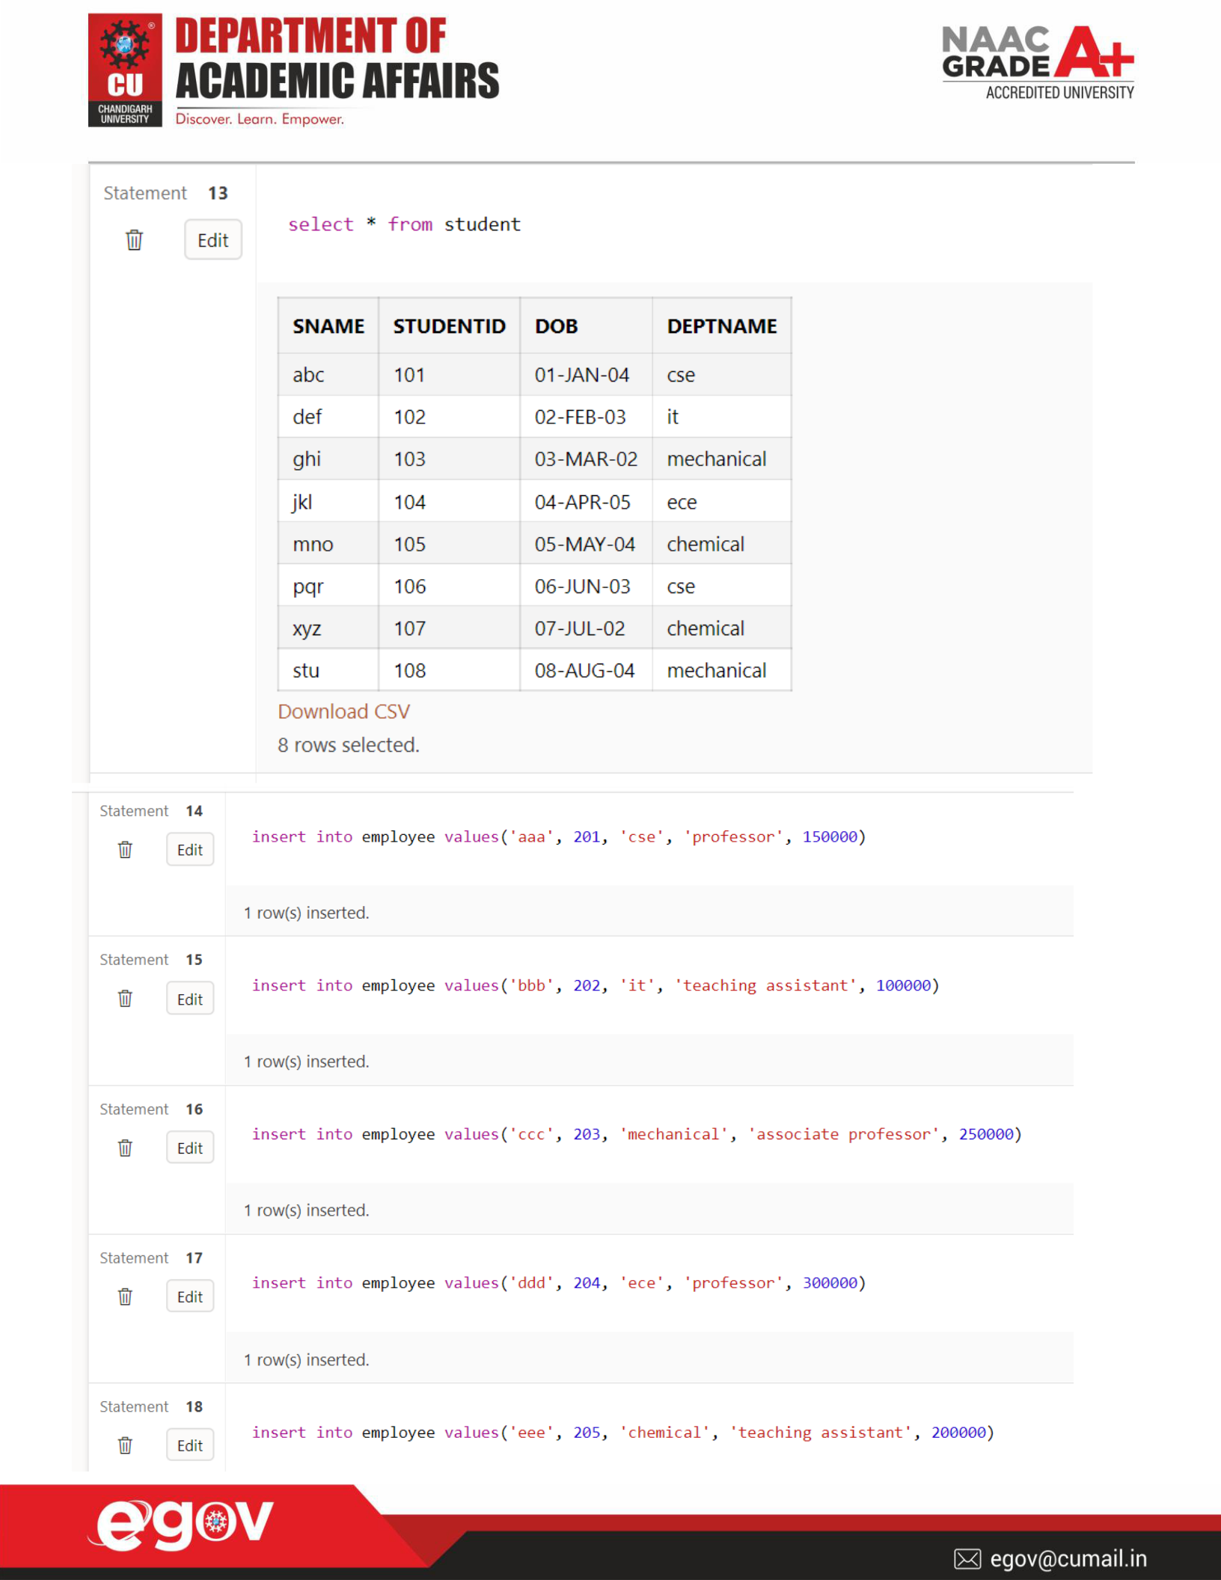
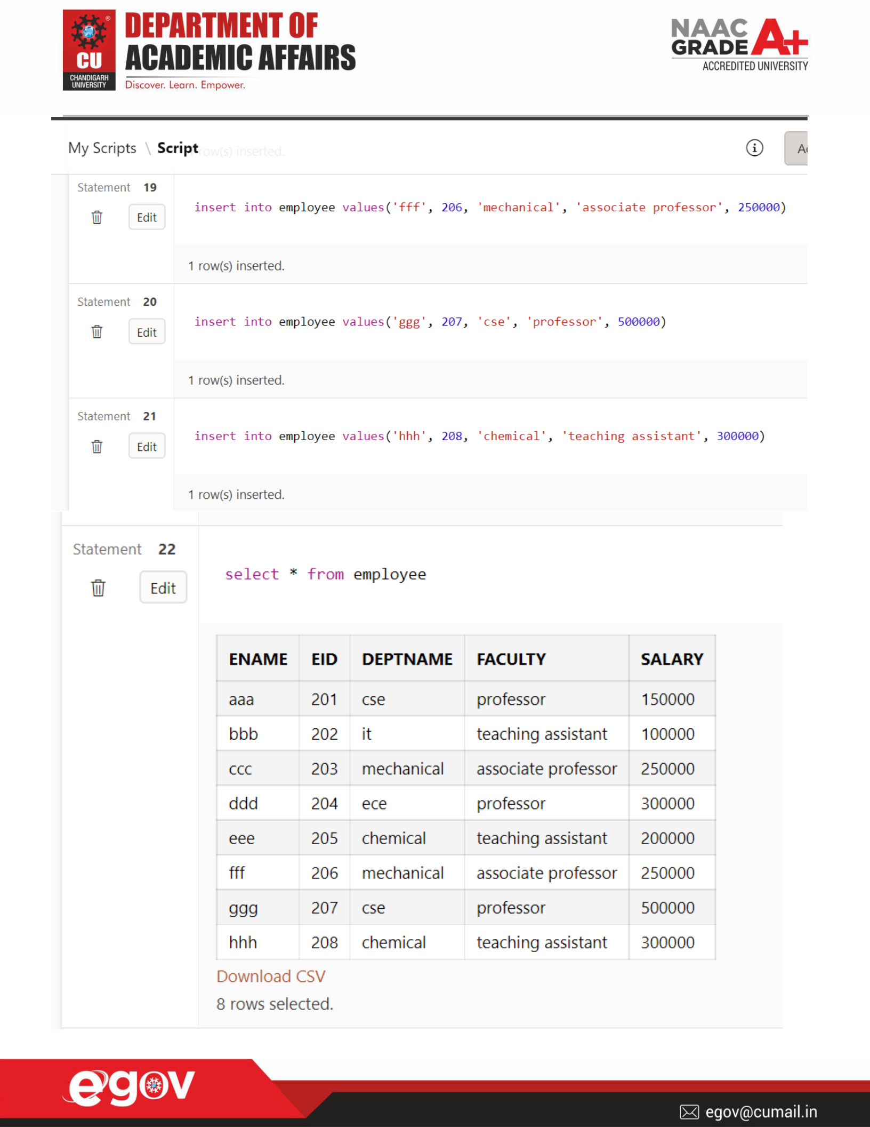

- List the details of students in the ascending order of date of birth
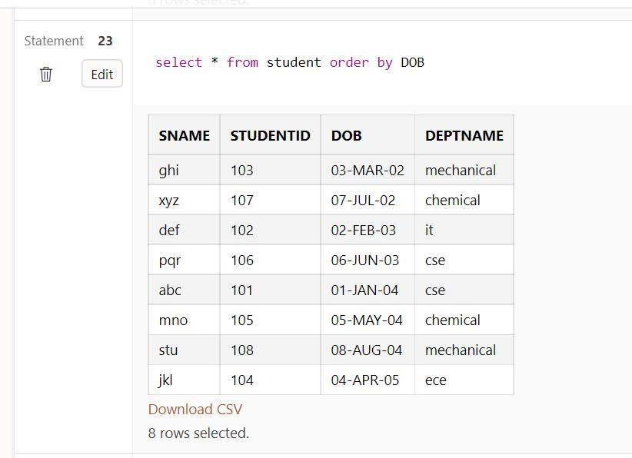

b. Display the details of students from computer department
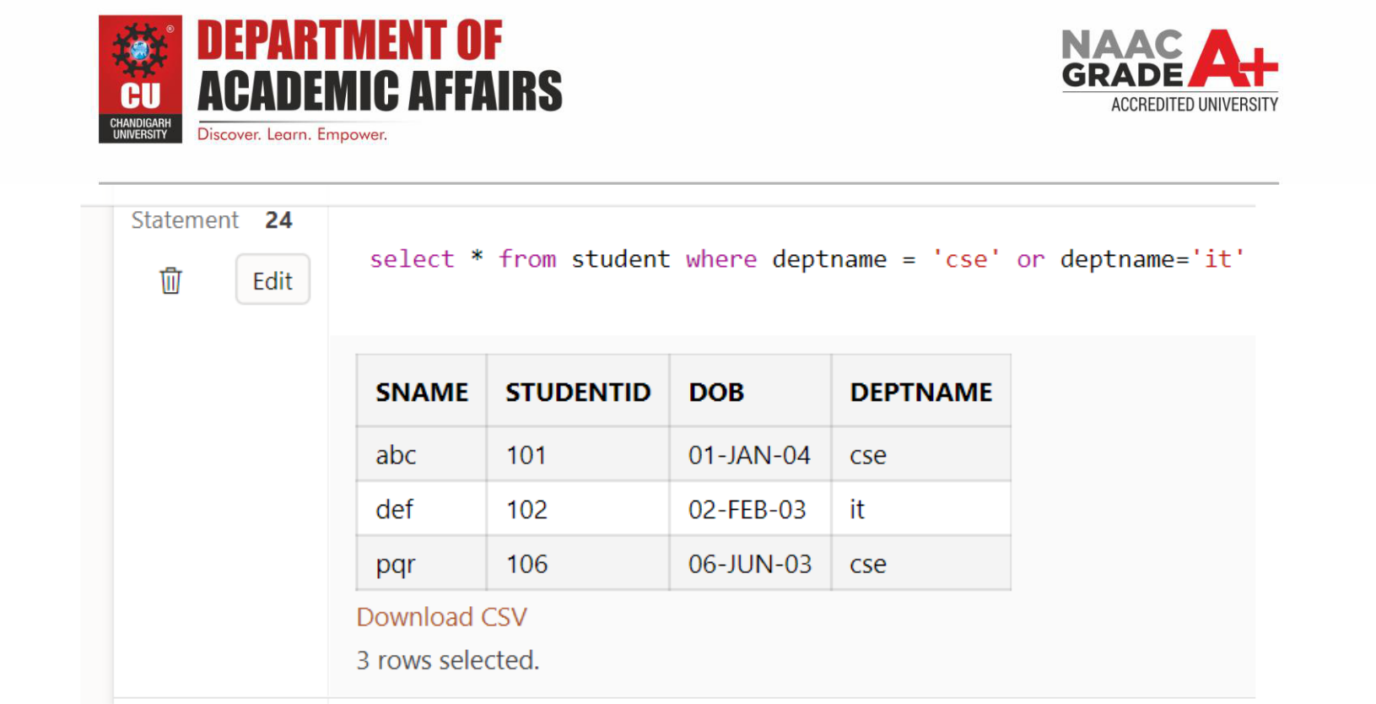

c. List the faculties in the descending order of salary
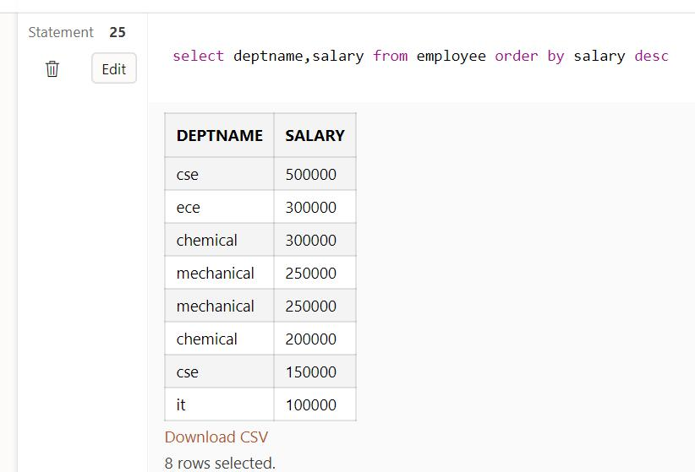
d. Display the total number of students in each department
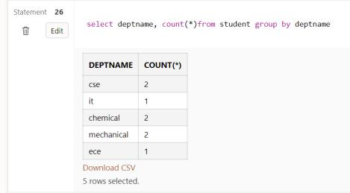

- Display the total number of faculties in each department with salary greater than 25000.
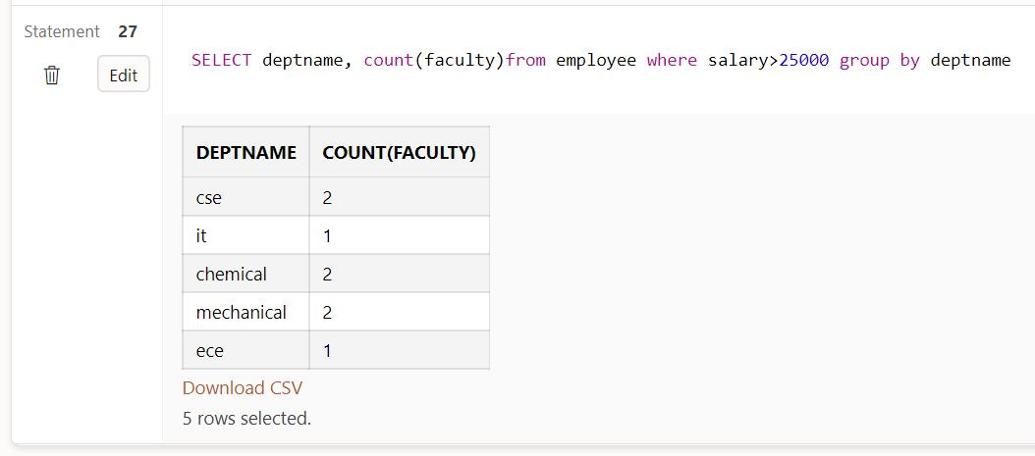

Evaluation Grid:

Sr. No.

Parameters

Marks Obtained

Maximum Marks

1. | Student Performance |  | 12
 | (Conduct of experiment)
 | objectives/Outcomes.
2. | Viva Voce |  | 10
3. | Submission of Work Sheet |  | 8
 | (Record)
 | Total |  | 30

